Tender Document

Supply of New Furniture


COMSATS University Islamabad
Park Road, Tarlai Kalan, Islamabad
051-9049-5122 / 051-9049-5154

Tender Notice
Supply of New Furniture
No.CUI/Proc/TN-332/7-23/332

- COMSATS University Islamabad (CUI) Islamabad, a Public Sector Educational Organization invites sealed tenders from renowned Sole Proprietor/ Firms/Companies registered with Income Tax and Sales Tax Departments and are on Active Taxpayer List of FBR (I.T & GST), for Supply of New Furniture.
- The procedure will be based upon “Single Stage-Two Envelope” bidding method as prescribed under PPRA rules.
- The sealed Financial Bids must be accompanied with the Earnest Money Rs. 200,000/- in the form of Call Deposit/Bank Draft (refundable) drawn in favor of “COMSATS University Islamabad” (FTN/NTN: 9013701-9).
- Tender documents are available online for the interested firms/Companies on PPRA website as well as CUI website which can be downloaded. Interested firms/bidders are required to submit their bids proposals along with tender fee of Rs.500/- (non-refundable) in shape of pay order/DD in favour of CUI Islamabad.
- Sealed bids (prepared in accordance with instructions of tender documents) must reach at the given address latest by July 18, 2023, at 1100 hrs. (Closing Time)
- Only Technical Bids will be opened on the same day half hour after the closing time in Room No. G-6, Faculty Block-I, COMSATS University Islamabad, park Road, Islamabad.

Mailing/Submitting Address


In-Charge (Procurement)
COMSATS University Islamabad
2nd Floor, Faculty Block-II, Park Road, Tarlai Kalan, Islamabad,
Tel: 051-90495242, 90495154, 051-90495122
Email: jawad@comsats.edu.pk

Eligibility & Qualification
Detail | Criteria | Envelope
- Draft of Earnest Money | Mandatory | In Financial Bid
- Bid /Quotation (Form No.1) (Strictly as per pattern) | Mandatory | In Financial Bid
Eligibility & Qualification in Technical bids |  | In Technical Bid
- Declaration Form (Form No.2) | Mandatory | In Technical Bid
- GST and NTN Registered | Mandatory | In Technical Bid
- Active Taxpayer List (ATL) of FBR, Status as “Active”. | Mandatory | In Technical Bid
- Proof of Non-Blacklisting:  Affidavit on legal paper of appropriate value (duly attested from notary public)/letterhead that the firm/company is neither blacklisted nor in litigation with any of its public sector client | Mandatory | In Technical Bid
- Technical Compliance sheet (From-3) | Mandatory | In Technical Bid
Professional Experience (Form No. 4)  List of 3 executed/ similar contracts in public sector/ government offices/Embassies etc from Last 3 Year (List 03 contracts). Each contract = 5 Marks each Total Marks = 15 (Attached proof: 3 Contract/Work Order, W.O of over Rs, 100,000 individually will be considered for marking). | 15 Marks | In Technical Bid
Clientele List (Form No.4)  List 03 different clients of similar nature contracts. total Marks = 15 Marks (5 Marks per client) (Attached proof: 3 Contract/Work Order, W.O of over Rs. 100,000 individually will be considered for marking). | 15 Marks | In Technical Bid
- One Sample is mandatory | Pass/Fail | In Technical Bid

Bids Evaluation Criteria:
- Bids will be evaluated in fair, transparent and non-discriminatory manner. For the purpose of determining the lowest evaluated bid, the above criteria shall be taken into consideration of bids.
- To be qualified, securing at least 70% Marks in technical evaluation is Mandatory.
- Failing to fulfill ANY of the Mandatory Requirement will disqualify the bidder from the process forthwith.
- After evaluation/marking of bidders in technical evaluation process, financial bids of technically qualified bidders will be only opened later on prior notice.
- A technical Committee will review the samples. The decision of the technical Committee will be final and binding on the bidders. Rejection of the sample by the technical committee will lead to disqualification of the bid.

General Terms & Conditions

1. The Terms & Conditions are as under:
No tender will be considered if: ‐
  - Received without required documentation or found incomplete.
  - Received later than the date and time fixed for Tender submission.
  - The Bid is unsigned/ unstamped.
  - The Tender is signed/stamped by the unauthorized agent of the Firm/company.
  - The Tender is from a firm/company which is blacklisted or in litigation of some sort with any Public-Sector Organization.
  - The Tender is received by telephone/telex/fax/telegram.
  - Tenders received without earnest money.
  - In contradiction with the specification given by the CUI.

- Bidders, who are on Active Taxpayers List (ATL) of FBR, both GST and Income Tax are eligible to apply.
- Bidders will have to produce proof of being a Tax Filer with FBR.
- Income tax as applicable and announced by the Govt. of Pakistan will be deducted at source.
- The payment will be made after successful completion of all items and the job.
- The tender must accompany earnest money as mentioned in the tender notice, in the form of Call Deposit/Bank draft (refundable) drawn in favor of COMSATS University Islamabad.
- The rates must be quoted as per pattern.
- Prices should be valid for 60 days.
- Any attempt by a bidder to influence the examination, evaluation, comparison, and post qualification of the Bids or Contract award decisions may result in the rejection of its bid.
- CUI reserves the right to accept or reject any or all tenders as per PPRA Rules 33.
No advance payment will be permissible.
- The Work will be given to the lowest evaluated bidder on the basis of most advantages of bid. In case the successful bidder(s) refuse to supply the item(s), the earnest money will be forfeited AND a ban from business with CUI for a period of Six Months will be imposed. Any timeline extension due to unavoidable circumstances will be granted by the central Purchase committee (CPC) of CUI Islamabad.
- The delivery of items/work completion must be made maximum within 8 Weeks’ time. In case of any force Majure event/National emergency/unavoidable circumstances, any time extension shall be accepted/ rejected on the decision of CPC forum, CUI, Islamabad.
- In case of delay in delivery/execution of work, 0.5% of the total bid will be deducted upto 10% max (additional 20 days for supply). In case of further delay, CUI will have the right to cancel the Work Order without any further information or communication and earnest money will be forfeited AND/OR a ban from business with CUI for a period of Six Months will be imposed. (Final decision to impose penalty or deduction in bid amount shall be decided by CPC, CUI Islamabad).
- In cases lowest evaluated bidder refuses or fails to supply the item(s)/execute the work within the deadline(s), the Work Order may be offered to the next lowest bidder provided that the difference between the 1st lowest bidder and 2nd lowest bidder (2nd-1st) is less than or equal to the earnest money (General Economic Principle). Same principle for 3rd, 4th lowest bidders and so on.
- In case of defects/non-compatibility/sub-standard at any stage (from supply till validity of warranty period), CUI will inform the bidder within 15 days-time and the bidder will arrange for work Job within 15 days’ time. In case of non-compliance, CUI will arrange the equipment OR part(s) from alternate source(s) and the charges/expense incurred on the equipment/part(s) will be deducted from the earnest money/Invoice/performance Guarantee of the vendor.
- Applicable Income tax and GST will be deducted at source/as per rules. In case of exemption, please mention and attach the proper documentation duly verified from the concerned tax authorities/FBR; however, CUI will be final authority to accept or reject the exemption certificate. In case of rejection, CUI will not be liable to any payment and the complete applicable taxes will be deducted by CUI. CUI will provide a certificate of tax deduction and the vendor may claim refund from Tax Authorities/FBR.
- In case any holiday is announced by the Govt. OR any other unforeseeable circumstances that prevent the tender from being opened on the date announced (Force Majure), the tenders will be opened on the VERY NEXT WORKING DAY. Time and venue of the tender will remain as mentioned in the tender notice.
- The documents prepared by the Bidder as well as all correspondence and documents relating to the Bid shall be in English only.
- The currency of the quotation would be in Pakistan Rupees only.
- In case of calculation error in the submitted bid, the unit price (GST exclusive) of quotation will be considered as valid.
22. Any proposal/tender received by CUI after the deadline will be returned un-opened to the bidder concerned. Delays in the mail or courier, delays of person in transit, or delivery of a proposal to the wrong office shall not be accepted as an excuse for failure to deliver a proposal at the proper place and time. It shall be the bidder’s responsibility to determine the manner in which timely delivery of his proposal will be accomplished either in person, by messenger or by mail to the concerned office (As mentioned in the tender notice).
23. Payment will be made as per actual quantity provided/supplied & accepted.
24. CUI is authorized to vary quantities at the time of establishing the contract or as decided latterly according to its requirement and budget as per PPRA rules.
25. Do not submit any other document other than demanded.
26. No request for correction will be entertained after opening of the bid.
27. Unit price will be taken upto 2 decimal points and total cost will be round-up to zero decimal.
28. It must be clearly understood by the contractor that no claim on account of market fluctuations will be entertained during the currency of this contract for any item of work included in the bill of quantities attached to the Agreement. In other words, it may be clearly understood that no request for escalation of rates will be entertained.
29. The work shall be measured for the units mentioned in the Schedule of Prices according to the Contract as determined by the Engineer from approved drawings; Specifications; Contract Documents.

FORM 1

[Letterhead of the Firm]

Ref No: |  | NTN:
Date: |  | GST:

Supply of New Furniture
FINANCIAL BID
S.N | Detail of Specifications | Qty | Unit Price (GST Excl) | GST Amount | Unit Price (GST INCL) | Total Cost including all taxes
1 | Alexa Double Desk with 2 Chairs  Desk Size L1400 x D500 x 750 mm H  Chair Size: Large (18 “x 18” seat height 18” inch H)  Desktop to be made of MDF Board with polished edges, base to be made of MS Round pipe powder coated finish having 1 Shelve Having  Chair seat & back to be made of MDF Board with polished edges. Base to be made of round 18 guage pipe. Powder coated finish.  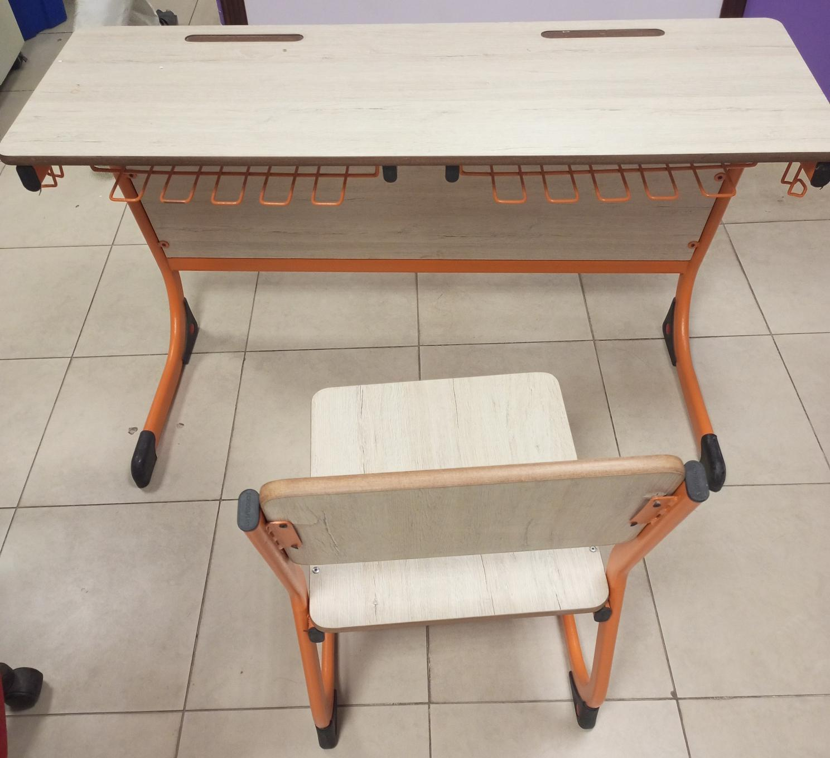 | 250 Set (2 Chair x 1 Table)
Total Cost including all taxes

Bid Valid as per given in the terms & conditions.
Signature:
Name:
Contact Information:
Official Stamp:

FORM-2
Declaration Form
(THIS FORM IS TO BE PROVIDED WITH THE BID)
All the terms & conditions have been carefully read and understood and are hereby unconditionally accepted and it is declared that:
I understand that by inserting any condition in my bid consciously or unconsciously will AUTOMATICALLY disqualify me from the bidding process.
All the information furnished by me/us here-in is correct to the best of my knowledge and belief.
I/we have no objection if enquiries are made about the work listed by me/us in the accompanying sheets /annexure.
I / We agree that the decision of committee(s) in selection will be final and binding to me/ us.
I/We have read the instructions appended to the proforma and I/we understand that if any false information in the documents is noticed at a later stage the committee is at liberty to act in a manner it feels deemed fit, which may include Penalty AND/OR forfeited of Earnest Money AND/OR Blacklisting for future tendering with CUI.

Tender No.
Name of Firm/ Company
Year of Establishment
Name of Owner/Authorized agent
Office Address
GST No.
NTN.
Valid Telephone No.
Valid E-mail
(For Official Correspondence)
Signature & Stamp
(Authorized Representative)

Form -3
[Letterhead of the Firm]
Ref No: |  | NTN:
Date: |  | GST:

Technical Compliance Performa
Supply of New Furniture
S.N | Detail of Specifications | Sample Mandatory | Compliance | Non-compliance | Higher Specs  If any
1 | Alexa Double Desk with 2 Chairs
1 | Desk Size L1400 x D500 x 750 mm H
1 | Chair Size: Large (18 “x 18” seat height 18” inch H)
1 | Desktop to be made of MDF Board with polished edges, base to be made of MS Round pipe powder coated finish having 1 Shelve Having.
1 | Chair seat & back to be made of MDF Board with polished edges. Base to be made of round 18 guage pipe. Powder coated finish.

Bid Valid as per given in the terms & conditions.
Signature: _________________ ___________________
Name: _________________
______________________________________
Contact Information: ______________
Official Stamp: _________________

Form-4

Detail of Work Executed since establishment.

SN | Organization & Address | Duration | Contact Information | Amount/Cost

Detail of Clients

SN | Organization & Address | Year of work executed | Contact Information

Attach Work Order/Contract Agreement for each of the above in above order as proof.
Bid will be rejected in case of non-provision of proof.
Filling of all fields are mandatory.

Check List (To be filled by Bidder)

Please submit your proposal in the order as below with
proper separators/Proper Binding/Plastic Cover/Staple

Detail | Status | Bid Envelope | Yes   | No  
- ALL Pages signed and Stamped by Bidder | Mandatory
- Draft of Earnest Money | Mandatory | Financial
- Bid (Form 1) | Mandatory | Financial
- Declaration Form (Form 2) | Mandatory | Technical
- GST and NTN Registered | Mandatory | Technical
- Press Declaration Certificate | Mandatory | Technical
- Active Taxpayer List (ATL) of FBR | Mandatory | Technical
- Proof of Non-Blacklisting: | Mandatory | Technical
- Technical Compliance Sheet (Form-3) | Mandatory | Technical
- Professional Experience (Form No.4) | Mandatory | Technical
- Clientele list (Form No.4) | Mandatory | Technical

For queries and further clarification, you may

- Write to us on jawad@comsats.edu.pk
- Visit us at 2nd Floor, Faculty Block-II, CUI, Islamabad

- Call us at 051-9049-5154/051-9049-5122/051-90405242.

