Tender Document

Supply of Wooden Lab Stools & Office Chair (Ergonomic Chair)



COMSATS University Islamabad
Park Road, Tarlai Kalan, Islamabad
051-9049-5122 / 051-9049-5154

Invitation to Bid
No.CUI/Proc/TN321/6-23/321
Supply of Wooden Lab Stools & Office Chair (Ergonomic Chair)
- COMSATS University Islamabad (CUI) Islamabad, a Public Sector Educational Organization invites sealed tenders from renowned sole proprietor / Firms/Companies registered with Income Tax and Sales Tax Departments and are on Active Taxpayer List of FBR (I.T & GST), for Supply of Wooden Lab Stools & Office Chair (Ergonomic Chair)
- The procedure will be based upon “Single Stage-Single Envelope” bidding method as prescribed under PPRA rules.
- The sealed Financial Bid must be accompanied with the Earnest Money Rs. 4,000/- in the form of Call Deposit/Bank Draft (refundable) drawn in favor of “COMSATS University Islamabad” (FTN/NTN: 9013701-9).
- Tender documents are available online for the interested firms/Companies on PPRA website as well as CUI website which can be downloaded. Interested firms/bidders are required to submit their bid proposals along with tender fee of Rs.500/- (non-refundable) in shape of pay order/DD in favor of CUI Islamabad.
- Sealed bids (prepared in accordance with instructions of tender documents) must reach the address given below latest by June 06, 2023, at 1100 Hrs (Closing time).
- Bids will be opened on the same day half hour after the closing time in Room No. G-6, Faculty Block-I, COMSATS University Islamabad, park Road, Islamabad.

Mailing/Submitting Address



In-Charge (Procurement)
COMSATS University Islamabad
2nd Floor, Faculty Block-II, Park Road, Tarlai Kalan, Islamabad,
Tel: 051-90495242, 90495154, 051-90495122
Email: jawad@comsats.edu.pk

Eligibility & Qualification:

Detail | Criteria
- Draft of Earnest Money | Mandatory
- Bid /Quotation (Form No.1)  (Strictly as per pattern) | Mandatory
- Declaration Form (Form No.2) | Mandatory
- GST and NTN Registered | Mandatory
- Active Taxpayer List (ATL) of FBR  Status as “Active” in I.T and Compliance Level is 100% in GST | Mandatory
- Proof of Non-Blacklisting:  Affidavit on legal paper of appropriate value (duly attested from notary public)/letterhead that the firm/company is neither blacklisted nor in litigation with any of its public sector client | Mandatory
- Compliance with Specification (Form 3) | Mandatory

Criteria for Tenders Evaluation and Award of Contract:
- Bids will be evaluated in fair, transparent and non-discriminatory manner. For the purpose of determining the lowest evaluated bid, the above criteria shall be taken into consideration of bids.
- The bidder fulfilling all the above criteria will be qualified.
- The work will be given to the lowest bidder on the basis of most advantages of bid.

General Terms & Conditions

1. The Terms & Conditions are as under:
No tender will be considered if: ‐
  - Received without required documentation or found incomplete.
  - Received later than the date and time fixed for Tender submission.
  - The Bid is unsigned/ unstamped.
  - The Tender is signed/stamped by the unauthorized agent of the Firm/company.
  - The Tender is from a firm/company which is blacklisted or in litigation of some sort with any Public-Sector Organization.
  - The Tender is received by telephone/telex/fax/telegram.
  - Tenders received without earnest money.
  - In contradiction with the specification given by the CUI.

- Bidders, who are on Active Taxpayers List (ATL) of FBR, both GST and Income Tax are eligible to apply.
- Bidders will have to produce the proof of being a Tax Filer with FBR.
- Income tax as applicable and announced by the Govt. of Pakistan will be deducted at source.
- The payment will be made after successful completion of all items and job.
- The tender must accompany earnest money as mentioned in the tender notice, in the form of Call Deposit/Bank draft (refundable) drawn in favor of COMSATS University Islamabad.
- The rates must be quoted as per pattern.
- Prices should be valid for 60 days.
- Any attempt by a bidder to influence the examination, evaluation, comparison, and post qualification of the Bids or Contract award decisions may result in the rejection of its bid.
- CUI reserves the right to accept or reject any or all tenders as per PPRA Rules 33.
- No advance payment will be permissible.
- The Work will be given to the lowest evaluated bidder on the basis of most advantages of bid. In case the successful bidder(s) refuse to supply the item(s), the earnest money will be forfeited AND a ban from business with CUI for a period of Six Months will be imposed. Any timeline extension due to unavoidable circumstances will be granted by the central Purchase committee (CPC) of CUI Islamabad.
- The delivery of items/work completion must be made maximum within 4 weeks’ time. In case of any force Majure event/National emergency/unavoidable circumstances, any time extension shall be accepted/ rejected on the decision of CPC forum, CUI, Islamabad.
- In case of delay in delivery/ execution of work, 0.5% of the total bid will be deducted upto 10% max (additional 20 days for supply). In case of further delay, CUI will have the right to cancel the Work Order without any further information or communication and earnest money will be forfeited AND/OR a ban from business with CUI for a period of Six Months will be imposed. (Final decision to impose penalty or deduction in bid amount shall be decided by CPC, CUI Islamabad).
- In cases lowest evaluated bidder refuses or fails to supply the item(s)/execute the work within the deadline(s), the Work Order may be offered to the next lowest bidder provided that the difference between the 1st lowest bidder and 2nd lowest bidder (2nd-1st) is less than or equal to the earnest money (General Economic Principle). Same principle for 3rd, 4th lowest bidders and so on.
- In case of defects/non-compatibility/sub-standard in supplies/work executed at any stage (from supply till validity of warranty period), CUI will inform the bidder within 15 days-time and the supplier/contractor will arrange supplies/correction in work within 15 days’ time.
- Applicable Income tax and GST will be deducted at source/as per rules. In case of exemption, please mention and attach the proper documentation duly verified from the concerned tax authorities/FBR; however, CUI will be final authority to accept or reject the exemption certificate. In case of rejection, CUI will not be liable to any payment and the complete applicable taxes will be deducted by CUI. CUI will provide a certificate of tax deduction and the vendor may claim refund from Tax Authorities/FBR.
- In case any holiday is announced by the Govt. OR any other unforeseeable circumstances that prevent the tender from being opened on the date announced (Force Majure), the tenders will be opened on the VERY NEXT WORKING DAY. Time and venue of the tender will remain as mentioned in the tender notice.
- The documents prepared by the Bidder as well as all correspondence and documents relating to the Bid shall be in English only.
- The currency of the quotation would be in Pakistan Rupees only.
- In case of calculation error in the submitted bid, the unit price (GST exclusive) of quotation will be considered as valid.
22. Any proposal/tender received by CUI after the deadline will be returned un-opened to the bidder concerned. Delays in the mail or courier, delays of person in transit, or delivery of a proposal to the wrong office shall not be accepted as an excuse for failure to deliver a proposal at the proper place and time. It shall be the bidder’s responsibility to determine the manner in which timely delivery of his proposal will be accomplished either in person, by messenger or by mail to the concerned office (As mentioned in the tender notice).
23. Payment will be made as per actual quantity provided/supplied & accepted.
24. CUI is authorized to vary quantities at the time of establishing the contract or as decided latterly according to its requirement and budget as per PPRA rules.
25. Do not submit any other document other than demanded.
26. No request for correction will be entertained after opening of the bid.
27. Unit price will be taken upto 2 decimal points and total cost will be round-up to zero decimal.

FORM 1

[Letterhead of the Firm]

Ref No: |  | NTN:
Date: |  | GST:

Supply of Wooden Lab Stools & Office Chair (Ergonomic Chair)
S.# | Detail of Specifications | Qty | Unit Price (GST Excl) | GST Amount | Unit Price (GST INCL) |  | Total Cost including all taxes
1 | Providing Lab Stools made with 2” x 2” Solid Kicker wood base 18” Round Top made with ¾” thick Plywood including foam and Cushion on top, polishing complete in all respect as per picture attached across (Size 2’ Height, width 14”, top 1’-6”)  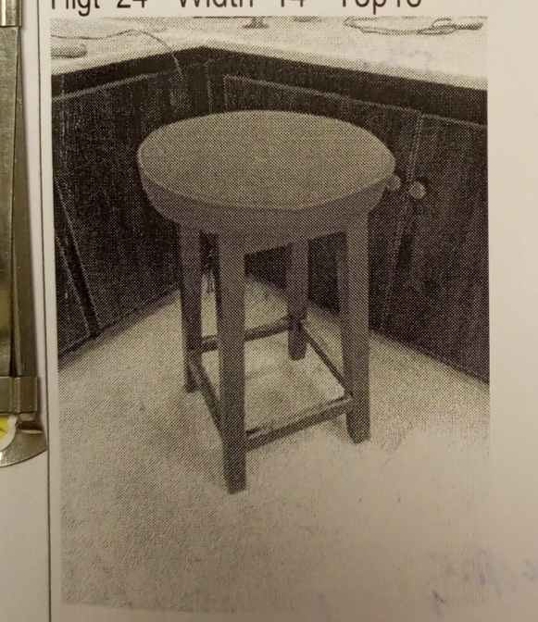 | 30 Nos
2 | Office Chair (Ergonomic Chair) High back hydraulic  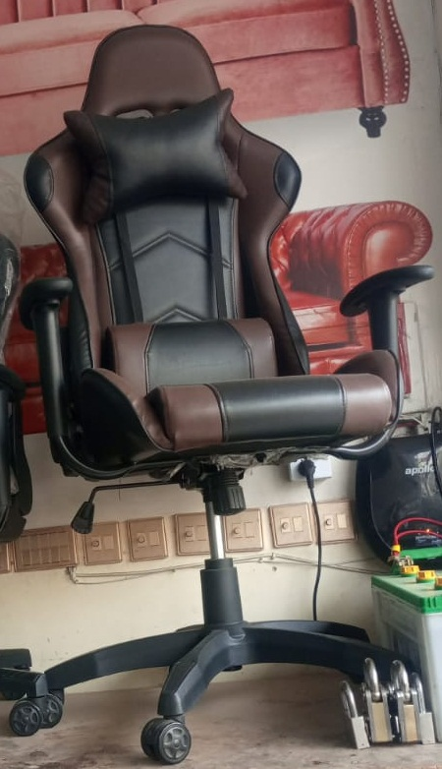 | 1
Total Cost including all taxes

Bid Valid as per given in the terms & conditions.
Signature:
Name:
Contact Information:
Official Stamp:

FORM-2
Declaration Form
(THIS FORM IS TO BE PROVIDED WITH THE BID)
All the terms & conditions have been carefully read and understood and are hereby unconditionally accepted and it is declared that:
I understand that by inserting any condition in my bid consciously or unconsciously will AUTOMATICALLY disqualify me from the bidding process.
All the information furnished by me/us here-in is correct to the best of my knowledge and belief.
I/we have no objection if enquiries are made about the work listed by me/us in the accompanying sheets /annexure.
I / We agree that the decision of committee(s) in selection will be final and binding to me/ us.
I/We have read the instructions appended to the proforma and I/we understand that if any false information in the documents is noticed at a later stage the committee is at liberty to act in a manner it feels deemed fit, which may include Penalty AND/OR forfeited of Earnest Money AND/OR Blacklisting for future tendering with CUI.

Tender No.
Name of Firm/ Company
Year of Establishment
Name of Owner/Authorized agent
Office Address
GST No.
NTN.
Valid Telephone No.
Valid E-mail
(For Official Correspondence)
Signature & Stamp
(Authorized Representative)

Form -3
[Letterhead of the Firm]
Ref No: |  | NTN:
Date: |  | GST:

Technical Compliance Performa
Supply of Wooden Lab Stools & Office Chair (Ergonomic Chair)
S.N | Detail of Specifications | Brand Offered If any | Compliance | Non-compliance | Higher Specs  If any
1 | Providing Lab Stools made with 2” x 2” Solid Kicker wood base 18” Round Top made with ¾” thick Plywood including foam and Cushion on top, polishing complete in all respect as per picture attached across (Size 2’ Height, width 14”, top 1’-6”)
2 | Office Chair (Ergonomic Chair) High back hydraulic

- Bid Valid as per the terms & conditions of tender documents.

Signature: _________________ ___________________
Name: _________________
______________________________________
Contact Information: ______________
Official Stamp: _________________

Check List (To be filled by Applicants)
This page must be placed on Top of the complete bidding document

Prepare & Submit the Bid in this Order
Detail | Yes   | No  
ALL Pages are signed and stamped
- Draft of Earnest Money
- Bid /Quotation – Form 1 (Strictly as per Pattern)
- Declaration Form – Form 2
- GST and NTN Registered
- Active Taxpayer List (ATL) of FBR
- Proof of Non- Blacklisting
- Compliance with Specification (Form 3)

For queries and further clarification, you may
- Write to us on jawad@comsats.edu.pk

- Visit us at 2nd Floor, Faculty Block-II, CUI, Islamabad

- Call us at 051-9049-5154/051-9049-5122

