Tender Document

Supply of Multimedia Projectors and Projection Screen

COMSATS University Islamabad
Park Road, Tarlai Kalan, Islamabad
051-9049-5122 / 051-9049-5154

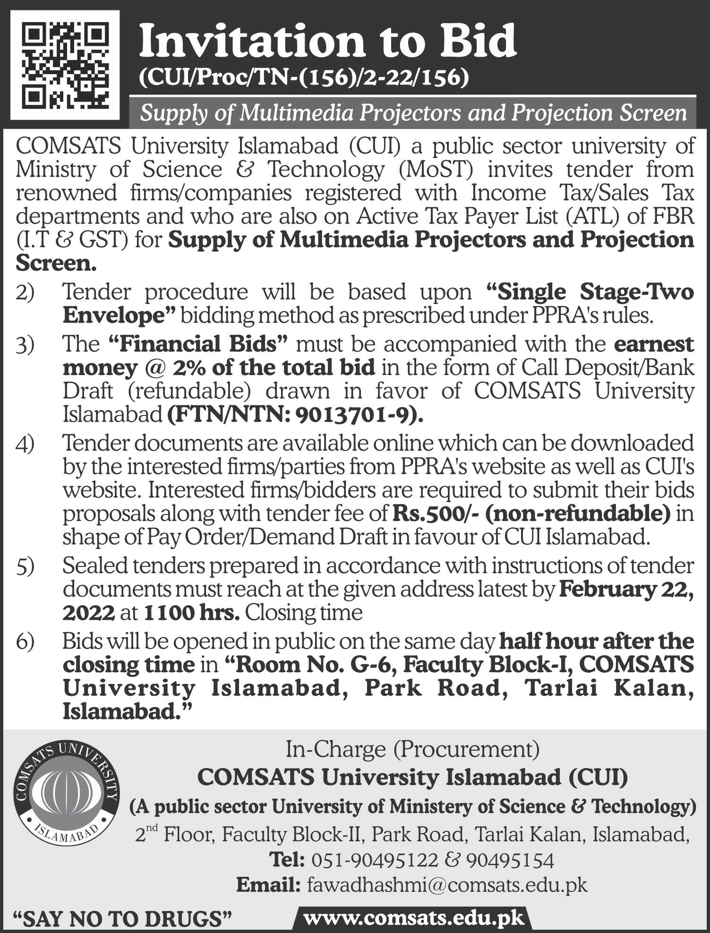

Eligibility & Qualification

Detail | Criteria | Envelope
- Draft of Earnest Money | Mandatory | In Financial Bid
- Bid /Quotation (Form No.1)  (Strictly as per pattern) | Mandatory
- Declaration Form (Form No.2) | Mandatory | In Technical Bid
- GST and NTN Registered | Mandatory
- Active Tax Payer List (ATL) of FBR  Status as “Active”. | Mandatory
- Proof of Non-Blacklisting:  Affidavit on legal paper of appropriate value (duly attested from notary public)/letterhead that the firm/company is neither black listed nor in litigation with any of its public sector client | Mandatory
- Warranty/Guarantee Terms  As per manufacture warranty required for serial no 1 of BOQ | Mandatory
- Authorized Dealer/Re- Seller  The bidder must provide authorized dealership/re-seller certificate of the brand. | Mandatory
- Technical Compliance sheet (From-3) | Mandatory
- Brochure  Detail of equipment, brands, country of origin with complete specification | Mandatory
- Professional Experience (Form No. 4)  - List of executed/ similar contracts in public sector/ government offices/Embassies etc since establishment.  (List 03 contracts). Each valid contract = 5 Marks each  Total Marks = 15  Copies of contract agreement/work order etc are mandatory | 15 Marks
12. Clientele List  List 05 different clients of similar nature contracts.  Total Marks = 15 Marks (3 Marks per client)  Copies of contract agreement/work order etc are mandatory | 15 Marks
- Technical Resources & Services Support  Mention in detail the in-house resources, facilities and technical support available from the bidder for  Installation= (3)  up-gradation,= (3)  configuration, = (3)  commissioning = (3)  and after sales services of equipment.= (3) | 15 Marks

Bids Evaluation Criteria:
- Bids will be evaluated in fair, transparent and non-discriminatory manner. For the purpose of determining the lowest evaluated bid, the above criteria shall be taken into consideration of bids.
- To be qualified, securing at least 70% Marks is Mandatory.
- Failing to fulfill ANY of the Mandatory Requirement will disqualify the bidder from the process.
- After evaluation/marking of bidders in technical evaluation process, financial bids of technically qualified bidders will be only opened later on prior notice.

General Terms & Conditions

1. The Terms & Conditions are as under:
No tender will be considered if: ‐
  - Received without required documentation or found incomplete;
  - Received later than the date and time fixed for Tender submission;
  - The Tender is unsigned/ unstamped;
  - The Tender is singed/stamped by the unauthorized agent of the Firm/company;
  - The Tender is from a firm which is black listed or in litigation of some sort with any Public-Sector Organization;
  - The Tender is received by telephone/telex/fax/telegram;
  - Tenders received without earnest money;
  - In contradiction with the specification given by the CUI;

- Suppliers, who are on Active Taxpayers List (ATL) of FBR, both GST and Income Tax are eligible to apply.
- Bidders will have to produce the proof of being a Tax Filer with FBR.
- Income tax as applicable and announced by the Govt. of Pakistan will be deducted at source.
- The payment will be made after successful completion of all items and job, for the item accepted by CUI.
- The tender must accompany earnest money as mentioned in the tender notice, of the total value of the bid in the form of Call Deposit/Bank draft (refundable) drawn in favor of COMSATS University Islamabad.
- The rates must be quoted as per pattern.
- Prices should be valid for 90 days.
- Quantity will be Vary as per actual requirement.
- Any attempt by a bidder to influence in the examination, evaluation, comparison, and post qualification of the Bids or Contract award decisions may result in the rejection of its bid.
- CUI reserves the right to accept or reject any or all tenders as per PPRA Rules 33.
- No advance payment will be permissible.
- The Work will be given to lowest evaluated bidder on the basis of lowest evaluated bid. In case the successful bidder(s) refuse to supply the item(s), the earnest money will be forfeited AND a ban from business with CUI for a period of ONE YEAR will be imposed.
- The Supply will be made within 8-12 weeks’ Time from the date of work Order. Ready stock will be given preference
- In case of delay in delivery, 0.5% of the total bid will be deducted upto 10% (additional 20 days for supply). In case of further delay, CUI will have the right to cancel the Work Order without any further information or communication and earnest money will be forfeited AND/OR a ban from business with CUI for a period of ONE YEAR will be imposed.
- 10% Performance Security would be withheld from the payment till the period of warranty.
- In cases lowest bidder refuses or fails to supply the item(s) within the deadline(s), the Work Order may be offered to the next lowest bidder provided that the difference between the 1st lowest bidder and 2nd lowest bidder (2nd-1st) is less than or equal to the earnest money (General Economic Principle). Same principle for 3rd, 4th lowest bidders and so on.
- In case of defects/non-compatibility/sub-standard at any stage (from supply till validity of warranty period), CUI will inform the bidder within 15 days-time and the bidder will arrange for replacement of the item(s) within 15 days’ time. In case of non-compliance, CUI will arrange the equipment OR part(s) from alternate source(s) and the charges/expense incurred on the equipment/part(s) will be deducted from the earnest money/Invoice/performance Guarantee of the vendor.
- Applicable Income tax and GST will be deducted at source/as per rules. In case of exemption, please mention and attach the proper documentation duly verified from the concerned tax authorities/FBR; however, if CUI will be final authority to accept or reject the exemption certificate and the vendor may claim refund from Tax Authorities/FBR.
- In case of any holiday is announced by the Govt. OR any other unforeseeable circumstances that prevent the tender from being opened on the date announced (Force Majure), the tenders will be opened on the VERY NEXT WORKING DAY. Time and venue of the tender will remain as mentioned in the tender notice.
- In case of Tie in rates, the bidder securing highest technical score in the criteria will be awarded the contract. In case of tie in technical Score, the bidder having the most valued work orders (work orders provided against relevant experience) will be awarded the Work Order.
- The documents prepared by the Bidder as well as all correspondence and documents relating to the Bid shall be in English only.
- The currency of the quotation would be in Pakistan Rupees only.
- In case of calculation error, the unit price will be considered as valid.
- Any proposal/tender received by CUI after the deadline will be returned unopened to bidder concerned. Delays in the mail or courier, delays of person in transit, or delivery of a proposal to the wrong office shall not be accepted as an excuse for failure to deliver a proposal at the proper place and time. It shall be the bidder’s responsibility to determine the manner in which timely delivery of his proposal will be accomplished either in person, by messenger or by mail to the concerned office..
- In case a firm/company submits two bids/options against our tender; the bid with the highest value/amount will be considered.
- Payment will be made as per actual quantity provided/supplied & accepted.
- CUI is authorized to vary quantities at the time of establishing the contract or as decided latterly according to its requirement and budget as per PPRA rules.
- Do not submit any other document other than demanded.
- No request for correction will be entertained after opening of the bid
Form 1
[Letterhead of the Firm]
Ref No: |  | NTN:
Date: |  | GST:
Financial Bid
Supply of Multimedia Projectors and Projection Screen

S.N | Detail of Specifications | Qty | Unit Price (GST Excl) | GST Amount | Unit Price (GST INCL)) | Total Cost including all taxes
01 | 3 LCD / LED Projector Technology  3600 Lumens  Resolution: 1280 x 800 pixels or Above  Contrast Ratio: 12000: 1 or Above  HDMI Connectivity  PC in HDMI  USB for Wireless Dongle  Auto Key stoning  Input for S-Video  20 Meter HDMI Cable Included  01 year Comprehensive Warranty / Additional Warranty is preferred Authorized Dealers only.  Installation Included | 16
02 | Remote Controlled Motorized Projector Screen  Size: 6x8 Feet (H x W)  Matt White  Wall Mount  Standard installation / accessories included | 24

Bid Valid as per given in the terms & conditions.
Signature: _________________ ___________________
Name: _________________
______________________________________
Contact Information: ______________
Official Stamp: _________________

Form 2
Declaration Form
(Mandatory)
(This form is to be provided with the Bid. Non-provision of this form will disqualify the bidder from the bidding process)

All the terms & conditions have been carefully read and understood and are hereby unconditionally accepted and it is declared that
I understand that by inserting any condition in my bid consciously or unconsciously will AUTOMATICALLY disqualify me from the bidding process.
All the information furnished by me/us here-in is correct to the best of my knowledge and belief.
I/we have no objection if enquiries are made about the work listed by me/us in the accompanying annexure.
I / We agree that the decision of committee in selection will be final and binding to me/us.
I / We have read the instructions appended to the proforma and I / we understand that if any false information is found at any stage, the committee is at liberty to act in a manner it feels deemed fit, which includes, but not limited to, confiscation of Security/Earnest Money AND/OR imposing a bar/restriction from future business with CUI AND/OR blacklisting.
Tender No.
Name of Firm/ Company
Year of Establishment
Name of Owner/Authorized agent
Office Address
GST No.
NTN.
Valid Telephone No.
Valid E-mail
(For Official Correspondence)
Signature & Stamp
(Authorized Representative)

Form -3
[Letterhead of the Firm]
Ref No: |  | NTN:
Date: |  | GST:

Technical Compliance Performa
Supply of Multimedia Projectors and Projection Screen

S.N | Detail of Specifications | Brand Offered | Compliance | Non-compliance | Higher Specs  If any
01 | 3 LCD / LED Projector Technology
 | 3600 Lumens
 | Resolution: 1280 x 800 pixels or Above
 | Contrast Ratio: 12000: 1 or Above
 | HDMI Connectivity
 | PC in HDMI
 | USB for Wireless Dongle
 | Auto Key stoning
 | Input for S-Video
 | 20 Meter HDMI Cable Included
01 year Comprehensive Warranty / Additional Warranty is preferred Authorized Dealers only.
Installation Included
02 | Remote Controlled Motorized Projector Screen
 | Size: 6x8 Feet (H x W)
 | Matt White
 | Wall Mount
 | Standard installation / accessories included

Bid Valid as per given in the terms & conditions.

Signature: _________________ ___________________
Name: _________________
______________________________________
Contact Information: ______________
Official Stamp: _________________

Form-4

Detail of Work Executed since establishment

SN | Organization & Address | Duration | Contact Information | Amount/Cost

Detail of Clients

SN | Organization & Address | Year of work executed | Contact Information

Attach Work Order/Contract Agreement for each of the above in above order as proof.
Bid will be rejected in case of non-provision of proof.
Filling of all fields are mandatory.

Check List (To be filled by Bidder)

Please submit your proposal in the order as below with
proper separators/Proper Binding/Plastic Cover/Staple

Detail | Status | Bid Envelope | Yes | No
- ALL Pages signed and Stamped by Bidder | Mandatory
- Draft of Earnest Money |  | Financial
- Bid (Form 1)
- Declaration Form (Form 2) |  | Technical
- GST and NTN Registered
- Active Tax Payer List (ATL) of FBR

- Proof of Non-Blacklisting:
- Warranty / Guarantee Terms
- Authorized Dealer/ Re- Seller
- Technical Compliance Sheet (Form-3)
- Brochure
- Professional Experience (Form No.4)
- Clientele list

- Technical Resources & Services support

For queries and further clarification, you may
- write to us on fawadhashmi@comsats.edu.pk
- Visit us at 2nd Floor, Faculty Block-II, CUI, Islamabad
- Call us at 051-9049-5122 / 051-9049-5154

