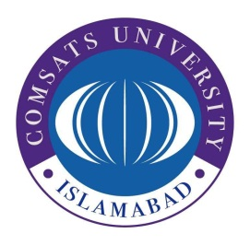
COMSATS University Islamabad
Park Road, Islamabad
Procurement Office
051-9049-5122 / 051 9049-5452

Subject: MINUTES OF PRE-BID MEETING
A Pre-Bid meeting was held on 11th October 2022 at 11:30 AM in Committee Room No.6, Faculty Block-2, CUI. The Pre-bid meeting was attended by the CPC members, end-user department (Exam Section).
The Pre-Bid meeting was held for the following tenders
Tender Title | PPRA Ref. No. | Tender Opening Date
Supply of Answer Sheets | TS491540E | 18th October 2022
Providing and Fixing of Back Drop Banner (Pana flex) for CUI Convocation 2022 | TS491707E | 18th October 2022
Printing of Invitation Cards for CUI Convocation | TS491706E | 18th October 2022

The meeting was attended by 04 interested bidders; the attendance is placed in the relevant case files. The general criteria and BoQ was explained to the bidders and special emphasis was on the Convocation tenders where it was again iterated that the successful bidder will have to comply with the deadlines.
Tender entitled “Printing of Invitation Cards for CUI Convocation”
The following points were clarified.
- The Convocation will be held in two sessions i.e., Morning & Evening, wherein the Program/Schedule will be different in both cards.
- Final text will be provided to the successful bidder and design will be approved before start of printing.
Tender entitled “Supply of Answer Sheets”
The following was clarified.
- Sample paper was shown to all bidders for printing of answer sheets
- The specification (Paper size and grammage) for Additional Sheet is the same as the Mid-Term and Terminal Exam specification. i.e., A-4 Size & 70gsm Imported Paper.

Habib Ullah
Assistant Program Officer - Procurement

Distribution:
- CUI Website for information of all bidders as per instruction of the tender document.
- CPC Members for information (via email)
- Relevant Tender Files

