CURRICULUM VITAE

PERSONAL DETAILS:
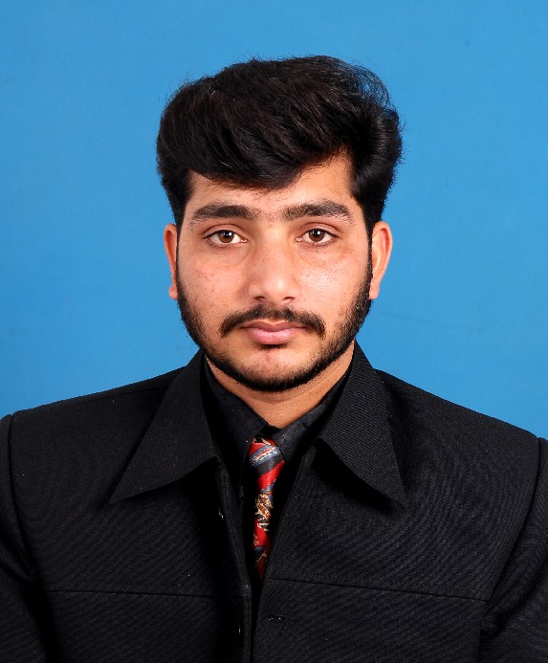

Name: Ikram-ul-haq

Fathers Name: Fazal-ul-haq

Date of Birth: 01-03-1985
Marital Status: Married
Domicile: Punjab
Nationality: Pakistani
N I C # 37405-7831827-1
Cell # 03181540849 03455906182
Email: ikramulhaq2003@gmail.com
Postal Address: Village Kotla, p/o Maira Mohra via Jhatta Hathial Teh & Dist. Rawalpindi.

OBJECTIVE:

To join an organization, which provides dynamic and competitive atmosphere to materialize my potential refine my capabilities for a bright future.

EDUCTION:
EXAMINATIONS | INSTITUTION/BOARD | YEAR | Duration | %AGE | GRADE | SUBJECT
B.Tech (Paas) | Preston university Islamabad | 2012 |  | 75% | C | Electrical
DAE | P.B.T.E Lahore | 2006 | 3 Years | 64% | B | Electrical
SSC | Govt. High School Jhatta Hathial Rawalpindi | 2002 | - | 60% | C | Science

TECHNICAL SKILLS:
CERTIFICARE | INSTITUTION | YEAR | Duration | GRADE | SUBJECTS
IT Advance Course | ABACUS College Of Computer & Managements Science | 2006 | 6 Months | A+ | MS-Office,  Architect, Software installation, internet. Networking.
AutoCAD | AUTOCAD Institute of Advance Technology | 2010 | 6 Months | A | 2D+3d
Certificate of Merit | COMSATS Institute of Information Technology. | 2012 | 1 Month | - | Communication Skills

WORK EXPERIENCE:

- Working in COMSATS Institute of Information Technology Islamabad as a Sr.Lab Assistant since 04, November 2009 to till date. I have done work in these labs and these are:
Electronics Lab
Circuits Lab
Electrical Machine Lab
Communications Lab

- I have 3 years’ experience in Hamdard University Islamabad as a Lab Assistant/Technician since 06, November 2006 to 02, November 2009.

P.T.O
  - Ability of handling all type of lab equipment such as,
- AC/DC Machines, transformers Singal phase, Three phase & Circuits
- Power supply
- Oscilloscope (Analog and Digital)
- Function Generator (Analog and Digital)
- Signal Generator
- Communication Trainer KL900A (Analog and Digital)
- Communication Trainer Lab Volt
- KL-21001 Trainer Liner Circuit Lab
- L.C.R, Tachometer & Multimeter etc
- Maintenance of PCs and software installation in PCs .

REFERENCES:

Adequate reference will be furnished if so desired.

